SMART ROAD ACCIDENT ANALYSIS AND SEVERITY PREDICTION USING MACHINE LEARNING
MANNET KAUR LATHA MALOTH
Department of Computer Science and Engineering Department of Computer Science and Engineering
Lovely Professional University, Punjab, India Lovely Professional University, Punjab, India
Email:lathamaloth318@gmail.com

ABSTRACT
Road accidents are influenced by road, vehicle, weather and other conditions. This project applies predictive analytics to a dataset of 10,000 records and 10 attributes to predict accident severity as fatal or non-fatal. Five machine learning models—Logistic Regression, Decision Tree, Random Forest, K-Nearest Neighbors (KNN) and Support Vector Machine (SVM)—are implemented. Model performance is evaluated using accuracy, precision, recall, F1-score, ROC-AUC and confusion matrices. The results show that Logistic Regression achieved the highest F1-score, while KNN achieved the highest accuracy. The models are compared to identify their effectiveness in classifying accident severity. This study demonstrates how machine learning techniques can be applied to analyse accident data and support road safety research.
Keywords—Road Accidents, Predictive Analytics, Accident Severity, Machine Learning, Classification, Logistic Regression, Random Forest, Support Vector Machine (SVM).
I. INTRODUCTION
Road accidents are a major public-safety concern caused by factors such as road conditions, vehicle types, weather and driving behaviour. Analysing accident data helps identify patterns and understand accident severity. This project uses machine learning techniques to predict accident severity as fatal or non-fatal using 10,000 accident records. Five algorithms—Logistic Regression, Decision Tree, Random Forest, KNN and SVM—are implemented and compared using different evaluation metrics. The main aim is to analyse accident data and understand the performance of different prediction models..
II. RELATED WORK
Previous studies have shown that machine learning techniques can be used to analyse road accident data and identify factors affecting accident severity. Different classification used to algorithms help predict accident outcomes based on road, vehicle and weather conditions. This project applies five machine learning algorithms—Logistic Regression, Decision Tree, Random Forest, KNN and SVM—to compare their performance in predicting fatal and non-fatal road accidents.
III. DATASET AND PREPROCESSING
A. Dataset Description
The dataset contains 10,000 records and 10 attributes related to road accidents. It includes details such as Incident_ID, State, Road_Type,Primary_Vehicle,Primary_Cause,Weather_Condition, Speed_Limit_KMH, Fatalities, Injuries and Accident_Severity. These attributes are used to analyse accident-related patterns and predict whether an accident is fatal or non-fatal.
Dataset item | Description
Records / attributes | 10,000 / 10
Prediction Task | Binary classification
Classification target | Accident_Severity
Severity classes | Fatal, Non-Fatal
Missing values | 0
TABLE I. DATASET DESCRIPTION
B. Preprocessing Steps
The program loads the Excel worksheet using pandas and displays the shape, first five records, data types and missing-value counts. Rows without Accident_Severity are removed. For simple regression, the input and target are converted to numeric values; infinite values are replaced and incomplete rows are removed. For multiple regression and classification, categorical features are one-hot encoded using drop_first=True. Infinite values are replaced and missing feature values are filled with column medians. Classification uses an 80:20 stratified train-test split with random_state=42. StandardScaler is fitted on training data and applied to test data for Logistic Regression and SVM; the Decision Tree uses unscaled features.

IV. METHODOLOGY — CLASSIFICATION
A.Classification Models: Three models predict Emergency_Response_Minutes. (1) Simple Linear Regression uses Speed_Limit_kmph as its single input. (2) Polynomial Regression applies PolynomialFeatures with degree=2 to the same input before fitting Linear Regression. (3) Multiple Linear Regression uses multiple accident attributes after removing Emergency_Response_Minutes, Accident_Severity and Record_ID from the inputs. The regression models use an 80:20 train-test split with random_state=42. The regression metrics are Mean Absolute Error (MAE), Mean Squared Error (MSE) and coefficient of determination (R²). Lower MAE and MSE indicate smaller prediction errors; R² indicates the proportion of target variance explained by the model.

.V. RESULTS AND DISCUSSION

A. Classification Results
Model | Accuracy | Precision | Recall | F1-Score
Logistic Regression | 0.5200 | 0.3630 | 0.5050 | 0.4224
SVM | 0.5315 | 0.3616 | 0.4547 | 0.3456
Decision Tree  Random Forest  KNN | 0.5305  0.5780  0.5785 | 0.3351  0.3247  0.3356 | 0.3568  0.1986  0.2173 | 0.4028  0.2464  0.2638
Table 2. Performance Comparison of Five Classification Models.
Logistic Regression gives the highest accuracy (66.75%) and Macro F1 (0.5559). SVM gives 64.75% accuracy, while Decision Tree gives the lowest accuracy (58.75%). SVM has the highest precision (0.5744).
B. Classification Model Performance
The figure compares the performance of five machine learning classification models: Logistic Regression, Decision Tree, Support Vector Machine (SVM), Random Forest, and K-Nearest Neighbors (KNN). The models are evaluated using different performance metrics, including accuracy, precision, recall, and F1-score. The comparison helps identify the strengths and weaknesses of each model in predicting road accident severity. It provides an overview of how effectively each algorithm classifies accidents into Fatal and Non-Fatal categories.
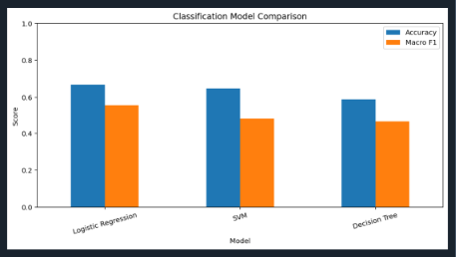
Fig. 1 Performance Metrics Comparison of Five Classification Models
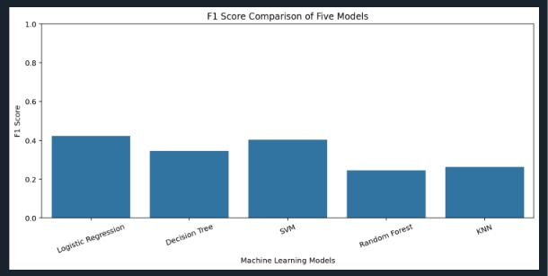
Fig. 2. F1-Score Comparison of Classifiers
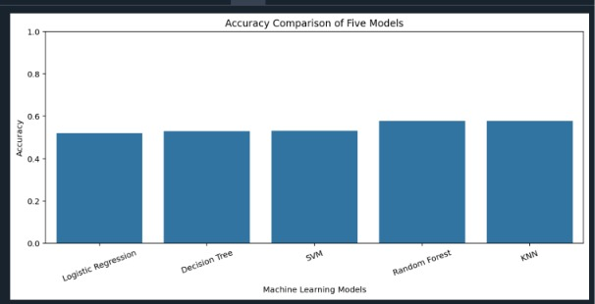
Fig. 3. Accuracy Comparison of Classifiers
C. Confusion Matrix
The diagonal values show correctly classified records. Logistic Regression correctly classified 22 Fatal, 202 Minor and 43 Serious records. Decision Tree correctly classified 18 Fatal, 185 Minor and 32 Serious records. SVM correctly classified 12 Fatal, 216 Minor and 31 Serious records.
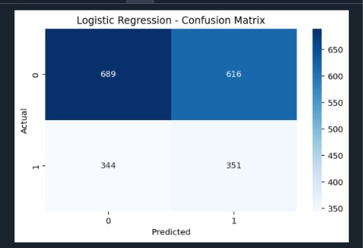

Fig. 4. Logistic Regression Confusion Matrix.
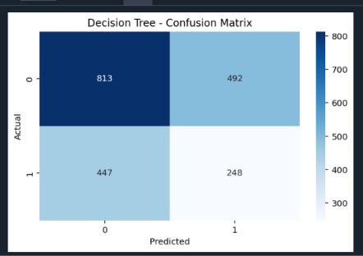

Fig.5. Decision Tree Confusion Matrix.

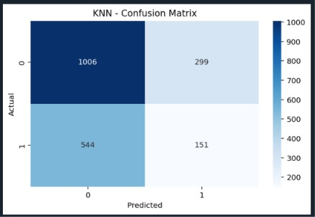

Fig. 6. KNN Confusion Matrix.

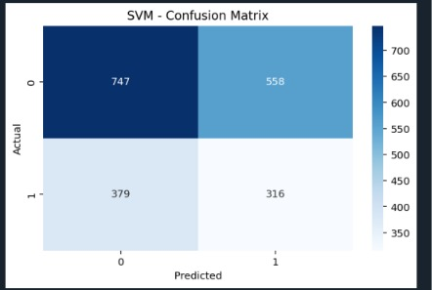

Fig. 4. SVM Confusion Matrix

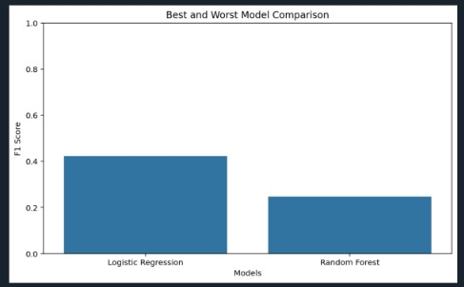

Fig. 5. Best and Worst Model Comparison

VI. LIMITATIONS
The project uses a dataset of 10,000 road accident records, and the accuracy of predictions depends on the quality and reliability of the available data. The model classifies accidents only into two categories: Fatal and Non-Fatal. The dataset may not represent all real-world road accident conditions. Some important factors influencing accident severity may not be included in the dataset. Additionally, the models may produce incorrect predictions due to variations in accident conditions and data patterns. Further testing with verified real-world datasets and additional relevant features is required to improve prediction performance.
VII. CONCLUSION
This project applied five machine learning classification algorithms to predict road accident severity as Fatal or Non-Fatal. Among the five models, Logistic Regression achieved the highest F1-score of 0.4224, while KNN achieved the highest accuracy of 57.85%. The results provide a comparison of different models and demonstrate the use of machine learning in road accident analysis.as validated real-world predictions. Future work can use verified accident data and further feature selection.
REFERENCES
[1] Python, Scikit-learn, Pandas, and Matplotlib Official Documentation.
[2] INT234 Predictive Analytics Course Materials, Lovely Professional University.
[3] Ministry of Road Transport and Highways, Government of India. Road Accidents in India – Annual Reports.
[4] NumPy Official Documentation.
[5] Seaborn Official Documentation.

